1) Englandskrigene 1801- 1814
Samtidig med det engelske angreb på de danske kolonier sendtes ca. ... Forsvaret af
selve København omfattede ca. 430 kanoner og morterer på de ...

Hvad drejer dette sig om? Har Danmark nogensinde været i krig med England?

2) Who was Horatio Nelson? What is his connection to Copenhagen?

Copenhagen 1801
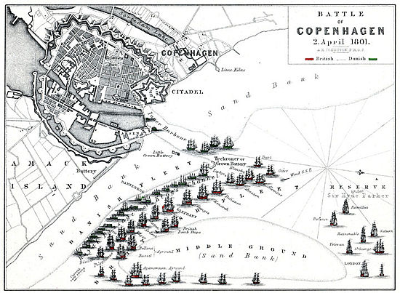
2 April 1801
When Denmark refused to leave the Armed Neutrality of the North Coalition, the Royal Navy moved to deprive the enemy of the Danish fleet.
The Danes had 18 ships in Copenhagen harbour, protected by a 66-gun battery and a wide area of shoals that made navigation difficult.
The British forces had 26 line of battle ships, seven frigates and a number of smaller craft.
When talks between the nations failed, the British commander Sir Hyde Parker moved by sending his deputy, Vice-Admiral Horatio Nelson, into battle with a dozen major warships.
Nelson took his ships around the shoals and prepared to make his attack. But several key vessels ran aground, including a floating battery meant to fire on the Danish gun emplacements, and a nervous Parker ordered a withdrawal.
Informed of the order, Nelson placed his telescope to his blind eye and said: "I have only one eye - I have a right to be blind sometimes. I really do not see the signal."
He then proceeded with the attack, pounding the Danish ships in a bloody action. Within two hours Nelson had just under 1000 men killed or wounded, while the Danes suffered almost 2000 casualties and a similar number of men captured.
In return for handing over the wounded, the British took 12 ships as prizes.

3) What is the relationship between Lord Nelson and the Copenhagen Fortifications?

Kastellet - Copenhagen Fortifications
Copenhagen has not always been a very peaceful place to live. In 1801 (when Nelson put the binocular before his blind eye and said the famous words: "I see no white flag!"), and again in 1807, the English fleet came calling (this time without Nelson), and these visits resulted in bombardments and sieges of Copenhagen, and the abduction of the Danish fleet. Because Denmark had chosen to support Napoleon instead of the allieds, Nelson was sent to deal with Denmark, and as the incident with the binocular indicates, Nelson was and is known for radical solutions, of which one is to totally remove any threat whenever possible. The British lived up to that tradition by invading Kastelled and keping troops there for six weeks in 1807.
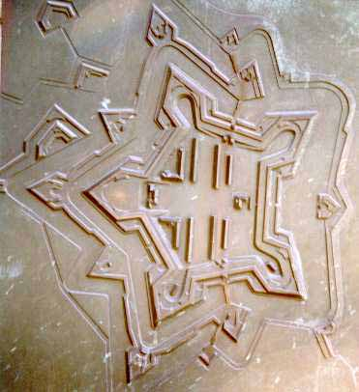
As far back as in 1626, an entrenchment was built by King Christian the Fourth in the Northern part of the defense wall of Copenhagen, in order to strengthen that section of the defenses. His second-oldest son, who succeded him on the throne, King Frederik the Third, decided to improve the defences on that spot even more, and "Kastellet" (Citadellet Frederikshavn) came into being. Finished in 1663, and located right behind "Den Lille Havfrue" (The Little Mermaid) and Langelinie, Kastellet was in its active days an almost self supplying fortification.

4) What has the Nelson Column at Trafalgar Square in London to do with Copenhagen?
The pedestal has on its four sides the following bronze reliefs.
North (facing the National Gallery), Rattle of the Nile: designed by W. F. Woodington. Nelson, having received a severe wound in the bead, was caught by Captain Berry in his arms, as he was falling, and carried into the cockpit; the surgeon is quitting a wounded sailor that he may instantly attend the Admiral. "No," said Nelson; "I will take my turn with my brave fellows." Some of the parts project 15 inches, and the figures are 8 feet high: the casting weighs 2 tons 15 cwt. 2 qrs.; and the metal is three-eighths of an inch thick.
South (facing Whitehall), Death of Nelson at Trafalgar: designed by C. E. Carew. Nelson is being carried from the quarter-deck to the cockpit by a marine and two seamen. "Well, Hardy," said Nelson to his captain, "they have done for me at last." "I hope not," was the reply. "Yes; they have shot me through the backbone." At the back of the centre group is the surgeon. To the left are three sailors tightening some of the ship's cordage; another kneels, holding a handspike and leaning on a gun, arrested by the conversation between the dying hero and Captain Hardy. In the front, lying on the deck, are an officer and marines, who have fallen to rise no more. Behind stand two marines and a negro sailor. One of the former has detected the marksman by whose shot Nelson fell, and is pointing him out to his companion. The latter has raised his musket, and has evidently covered his mark; whilst the black, who stands just before the two marines, is grasping his firelock. The figures are of life-size; the casting weighs about five tons. Beneath are Nelson's memorable words, "England expects every man will do his duty."
East (facing the Strand), Bombardment of Copenhagen: designed by the late Mr. Ternouth. Nelson is sealing, on the end of a gun, his despatch to send by the flag of truce; a group of officers surround him, and a sailor holds a candle and lantern: in the foreground are wounded groups; and in the distance are a church and city (Copenhagen) in flames.
West (facing Pall Mall), Battle of St. Vincent: commenced by Watson and finished by Woodington. Nelson, on board the San Josef, is receiving from the Spanish admirals their swords, which an old Agamemnon is putting under his arm; in the foreground is a dying sailor clasping a broken flag-staff.
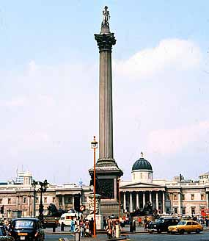
The Nelson Column, Trafalgar Square, of Portland stone, l45 ft. high, erected by public subscription in 1840-43, from designs by Railton. The statue which surmounts it was executed by E. H. Baily, R.A. The capital is of bronze, from French guns captured by the great Admiral, and is adorned with four bas-reliefs: the Victory off Cape St. Vincent, by Watson; the Bombardment of Copenhagen, by Ternouth; the Victory of the Nile, by Woodington; and the Death of Nelson, by Carew. Four colossal lions, carved in granite, by Sir E. Landseer, will surmount the four angles of the base as soon as completed.
Cruchley's London in 1865 : A Handbook for Strangers, 1865

5) Why has the area around St. Alban’s church been named “The Churchill Park”?
6) Who was Winston Churchill?
7) What is the connection between Churchill and Denmark?
8) Hvad forestiller billedet? Hvor står dette monument”
